Q:- consider a PL/SQL code that accepts 2 numbers & return addition, subtraction,multiplication,division of two numbers using stored functions and local functions.
Solution:-
CREATE OR REPLACE FUNCTION add_numbers(num1 IN NUMBER, num2 IN NUMBER)
RETURN NUMBER IS
BEGIN
RETURN num1 + num2;
END add_numbers;
/

CREATE OR REPLACE FUNCTION subtract_numbers(num1 IN NUMBER, num2 IN NUMBER)
RETURN NUMBER IS
BEGIN
RETURN num1 - num2;
END subtract_numbers;
/
CREATE OR REPLACE FUNCTION multiply_numbers(num1 IN NUMBER, num2 IN NUMBER)
RETURN NUMBER IS
BEGIN
RETURN num1 * num2;
END multiply_numbers;
/
CREATE OR REPLACE FUNCTION divide_numbers(num1 IN NUMBER, num2 IN NUMBER)
RETURN NUMBER IS
BEGIN
IF num2 = 0 THEN
RETURN NULL;
ELSE
RETURN num1 / num2;
END IF;
END divide_numbers;
/
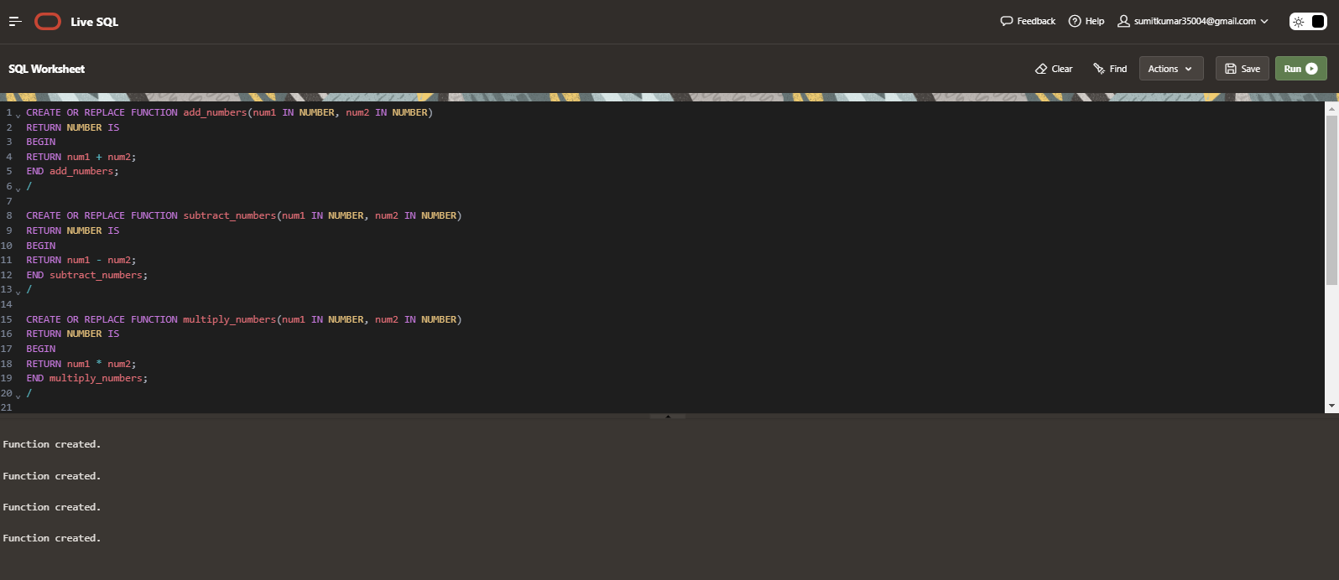

CREATE OR REPLACE PROCEDURE perform_operations(
num1 IN NUMBER,
num2 IN NUMBER) IS

FUNCTION local_add(n1 IN NUMBER, n2 IN NUMBER) RETURN NUMBER IS
BEGIN
RETURN n1 + n2;
END local_add;

FUNCTION local_subtract(n1 IN NUMBER, n2 IN NUMBER) RETURN NUMBER IS
BEGIN
RETURN n1 - n2;
END local_subtract;

FUNCTION local_multiply(n1 IN NUMBER, n2 IN NUMBER) RETURN NUMBER IS
BEGIN
RETURN n1 * n2;
END local_multiply;

FUNCTION local_divide(n1 IN NUMBER, n2 IN NUMBER) RETURN NUMBER IS
BEGIN
IF n2 = 0 THEN
RETURN NULL;
ELSE
RETURN n1 / n2;
END IF;
END local_divide;

BEGIN

DBMS_OUTPUT.PUT_LINE('Addition (Local): ' || local_add(num1,num2));

DBMS_OUTPUT.PUT_LINE('Subtraction (Local): ' || local_subtract(num1,num2));

DBMS_OUTPUT.PUT_LINE('Multiplication (Local): ' || local_multiply(num1,num2));

DBMS_OUTPUT.PUT_LINE('Division (Local): ' || local_divide(num1,num2));

DBMS_OUTPUT.PUT_LINE('Addition (Stored): ' || add_numbers(num1,num2));

DBMS_OUTPUT.PUT_LINE('Subtraction (Stored): ' || subtract_numbers(num1,num2));

DBMS_OUTPUT.PUT_LINE('Multiplication (Stored): ' || multiply_numbers(num1,num2));

DBMS_OUTPUT.PUT_LINE('Division (Stored): ' || divide_numbers(num1,num2));
END perform_operations;
/
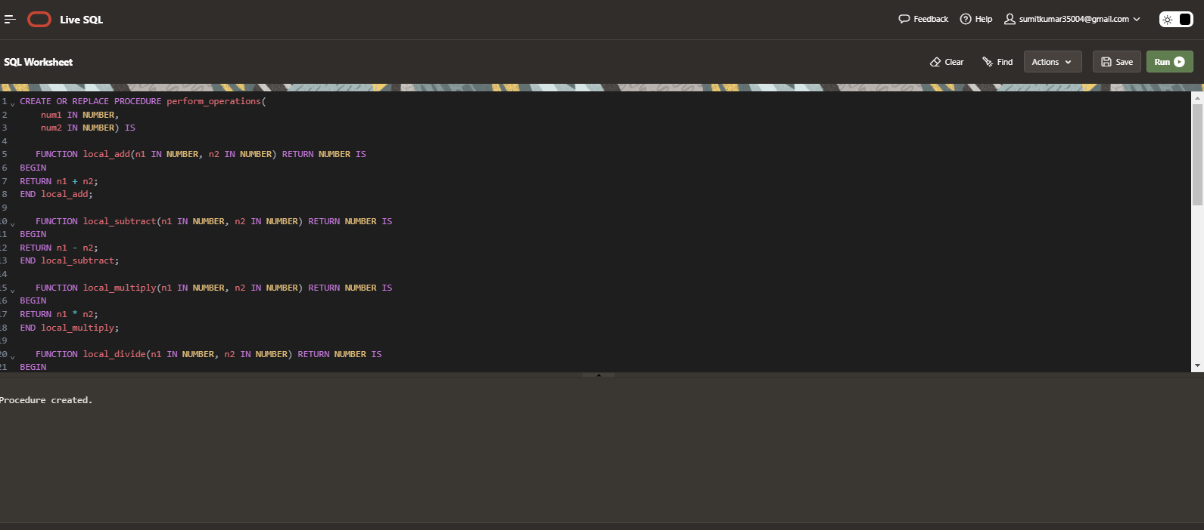

EXEC perform_operations(10,15);
